Self-Monitoring Form

During _________________, it is important to be quiet. This means that your mouth is closed, and no sounds are coming from it.

First, we will practice showing quiet and noisy. Check the box. Was it quiet or noisy?
When the timer goes off, check the box, were you quiet (expected) or noisy (unexpected?)

Remember, when we have something to say, we can raise our hand and wait for the teacher to call on us. That is the right way to participate in class!

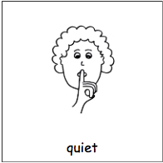

Quiet  Noisy  Quiet  Noisy  Quiet  Noisy  Quiet  Noisy | Quiet  Noisy  Quiet  Noisy  Quiet  Noisy  Quiet  Noisy

